JAVA with DSA

LECTURE 01 – FLOWCHART, PSEUDOCODE & BASICS

What is Programming ?
- Programming
- Process of given set of instructions to a computer to perform a specific task.
- Computer takes input, process via instructions, give output.
- These instructions are called Program.
- The logic / approach we think of is converted into a Programming Language (like Java) that the machine understands.
- Machine understand only 0s and 1s, so high-level codes get converted accordingly.
- Programming is the process of providing a computer with a set of logical instructions to perform a desired task, converting human logic into a machine understandable language.

What is an Algorithm ?
- Algorithm
- A series / sequence of steps used to perform a task or solve a problem.
- It is the logic / approach / solution we think of in our mind to solve a problem.
- Algorithm is written before coding – it’s the plan.
- Once algorithm is ready, it is converted into a programming language (like Java) and fed to the machine.
- Example:
- STEP 1: Boil water.
- STEP 2: Add Maggi noodles.
- STEP 3: Add Maggi Masala.
- STEP 4: Let it boil.
- Maggi is Ready !!!
- This sequence of steps Algorithm

How to Approach a Problem
When facing any problem (Math, Coding, English, etc) follow these 3 steps:
- STEP 1: Understand the Problem
- Read the problem statement carefully.
- Understand exactly what is being asked.
- Clarify the requirement before jumping to solution.
- STEP 2: Identify given values (Inputs)
- Note down all the given / input values separately.
- This helps keep track of available data while designing the logic.
- Prevents missing important constraints later.
- STEP 3: Think of the Approach / Algorithm
- Based on understanding + given values, build out logic / algorithm.
- Decide how these values can be utilized to reach the solution.

For Interview:
- To approach any problem:
- 1st understand it clearly, list down the given inputs / constraints, then design a logic algorithm to reach the solution.

Flowchart & its Components

What is a Flowchart ?
- A Flowchart = Diagrammatic representation of an Algorithm.
- Same logic / algorithm that was in text format is now represent in diagram format.
- Helps visualize the flow of execution of a program.

Component of a Flowchart
COMPONENT | SHAPE | PURPOSE
Terminal Block | Oval / Rounded Rectangle | To Start or End a Flowchart
Input / Output Block | Parallelogram | To take input or print / display output.
Processing Block | Rectangle | For calculations or value assignment (e.g., sum = a + b)
Decision Making Block | Diamond | For conditions – has true / false path.
Link (Arrow) | Arrows | To connect block and show flow direction.

Detailed Breakdown
- Terminal Block:
- Oval or rounded rectangle shaped.
- Used only for start / end of flowchart.
- Input / Output Block:
- Parallelogram Shaped.
- Used for: Taking input (e.g., input A, B) and printing output (e.g., Print Sum).
- Processing Block:
- Rectangle Shaped.
- Used for :
- Assignment: sum = 0, i = 1
- Calculation: sum = a + b
- Decision Making Block:
- Diamond Shaped.
- Contains a condition that evaluates the true / false
- 2 path emergency true path / false path.
- Example:
- name = “Shubham” true goes one way, false goes another.
- Links:
- Arrow connecting all blocks.
- Show execution flow / direction.

Example Flowchart (Sum of 2 numbers a + b)

Pseudocode
- Pseudo Fake / Dummy.
- Code Code
- So, Pseudocode Fale Code – it is NOT written in any real programming language.
- It is the logic / algorithm in plain, human-understandable language (English, Hindi, or any language).
- Used to roughly outline our approach before actual coding.

Key Characteristics
- No fixed syntax / rules – written in simple, understandable steps.
- Different people can write pseudocode differently for the same problem – all are valid as long as logic is clear.
- Acts as a bridge between Algorithm (thought process) and actual code (Java / C++ / Python).

Example
Sum of 2 numbers (a + b)
- STEP 1: Start
- STEP 2: Take input from user for a & b
- STEP 3: Add a & b, store result in sum
- STEP 4: Print sum
- STEP 5: End
Start / End steps are optional – even just 3 middle steps are acceptable.

Another Example
Average of a, b, c
- STEP 1: Start
- STEP 2: Take input for a, b, c
- STEP 3: Average = (a + b + c) / 3
- STEP 4: Print Average
- STEP 5: End

Another Example
Pseudocode with Decision Making (Positive / Negative / Zero check)
- STEP 1: Start
- STEP 2: Input number
- STEP 3: if number > 0 Print Positive Go to STEP 6
- STEP 4: if number < 0 Print Negative Go to STEP 6
- STEP 5: Print Zero
- STEP 6: End

Design a Flowchart & Pseudocode

Print the sum of 2 numbers a & b
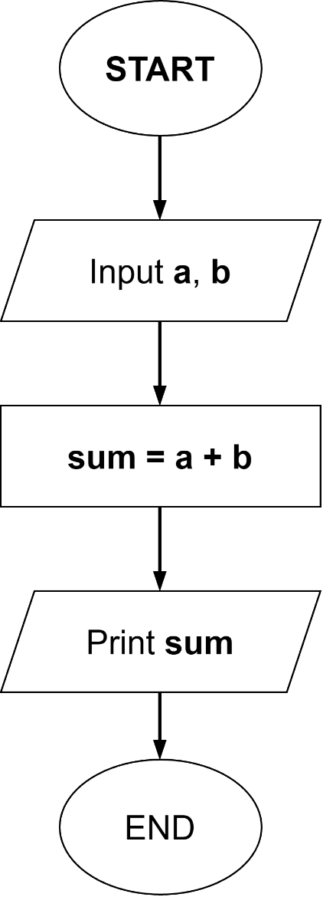
- STEP 1: Start
- STEP 2: Take inputs for a, b
- STEP 3: sum = a + b
- STEP 4: Print sum
- STEP 5: End

Print average of a, b, c
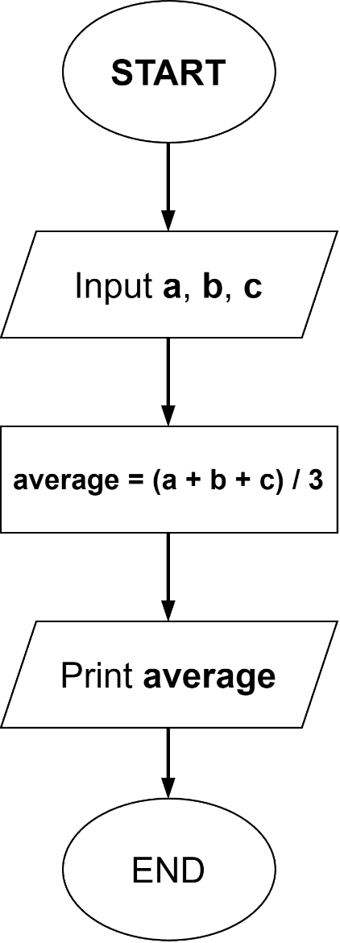
- STEP 1: Start
- STEP 2: Take input for a, b, c
- STEP 3: Average = (a + b + c) / 3
- STEP 4: Print Average
- STEP 5: End

Take input, add 3 numbers & print
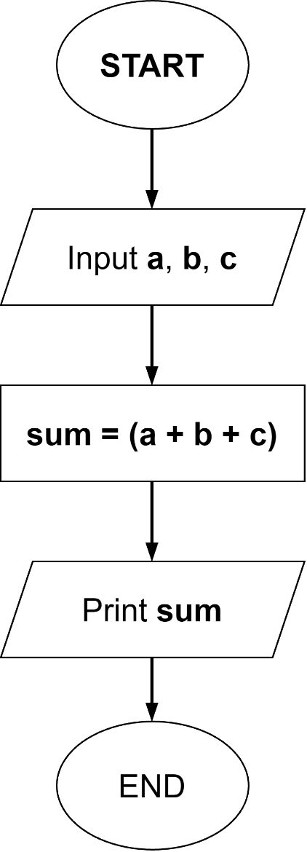
- STEP 1: Start
- STEP 2: Take input for a, b, c
- STEP 3: sum = (a + b + c)
- STEP 4: Print sum
- STEP 5: End

Print area of rectangle
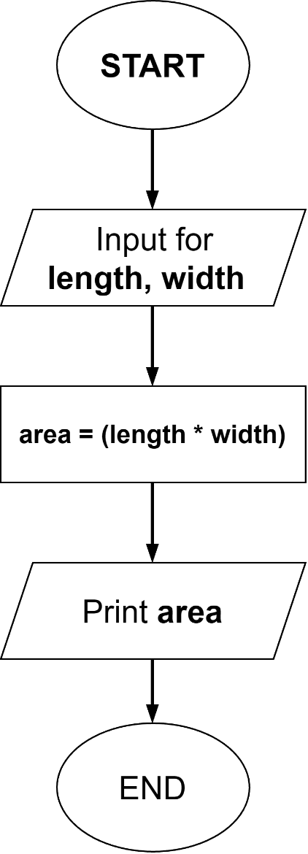
- STEP 1: Start
- STEP 2: Take input for length, width
- STEP 3: area = (length * width)
- STEP 4: Print area
- STEP 5: End

Check +ve, -ve, zero
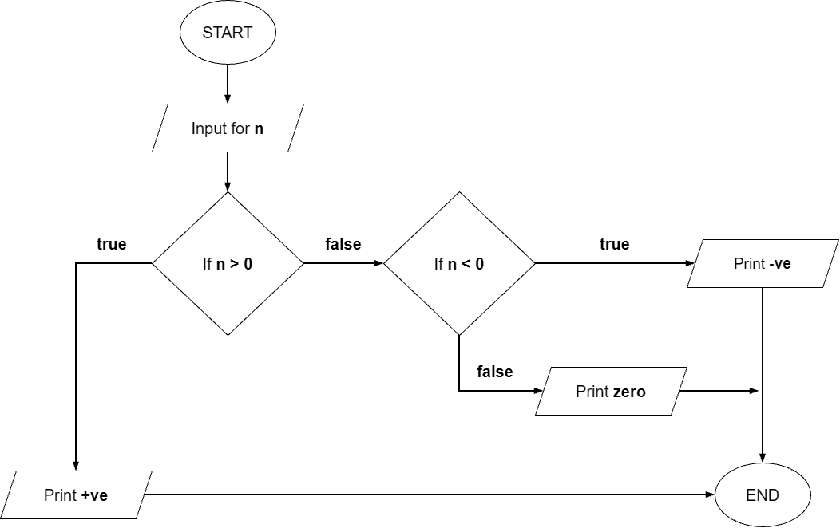
- STEP 1: Start
- STEP 2: Take input for n
- STEP 3: if n > 0 print +ve Go to STEP 6
- STEP 4: if n < 0 print -ve Go to STEP 6
- STEP 5: Print zero
- STEP 6: End

Print counting from 1 to n
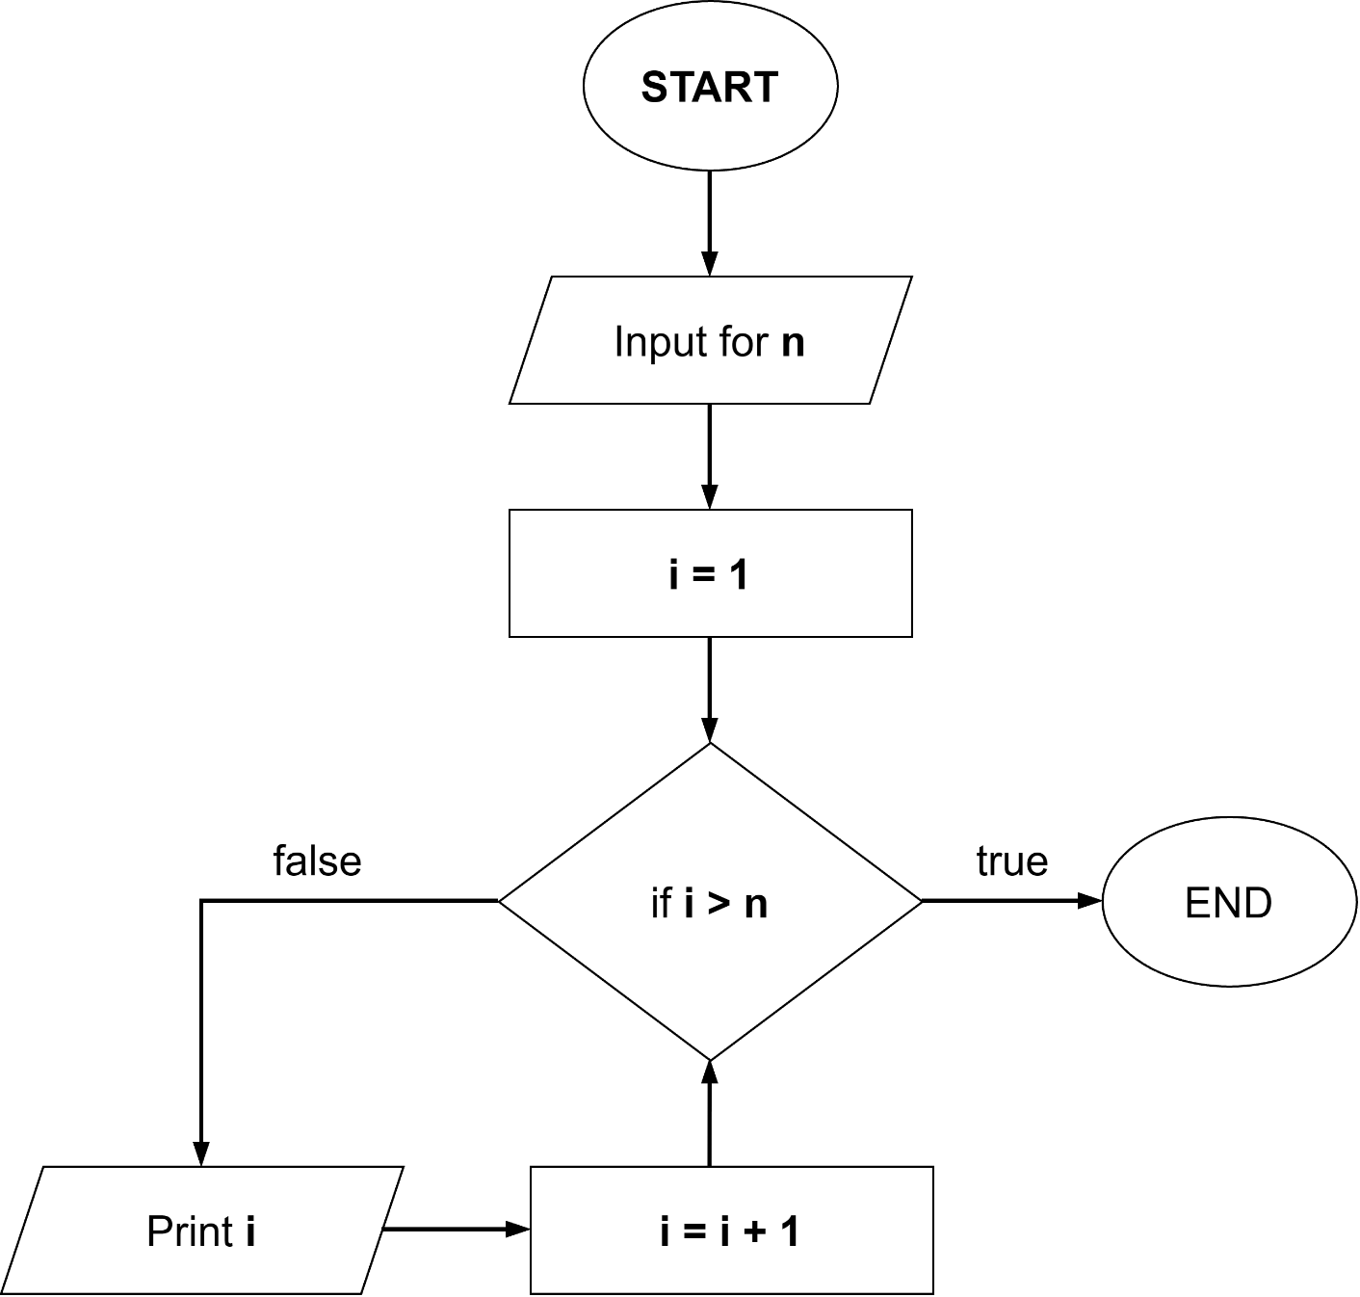
- STEP 1: Start
- STEP 2: Take input for n
- STEP 3: i = 1
- STEP 4: if i > n Go to STEP 7
- STEP 5: Print i
- STEP 6: i = i + 1 Go to STEP 4
- STEP 7: End

Print even number from 1 to n
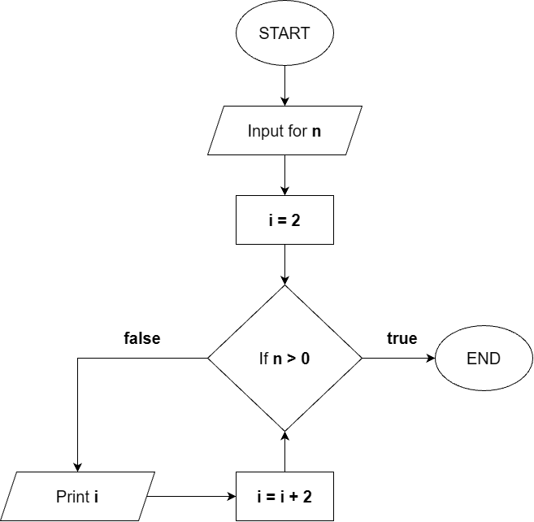
- STEP 1: Start
- STEP 2: Take input for n
- STEP 3: i = 2
- STEP 4: if i > n Go to STEP 7
- STEP 5: Print i
- STEP 6: i = i + 2 Go to STEP 4
- STEP 7: End

Take 2 input, multiply them & Print
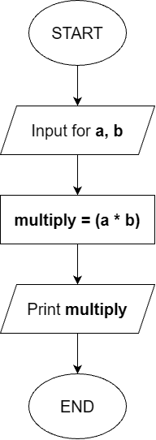
- STEP 1: Start
- STEP 2: Take input a, b
- STEP 3: multiply = (a * b)
- STEP 4: Print multiply
- STEP 5: End

Find & Print Simple Interest
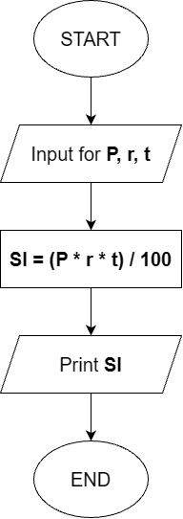
- STEP 1: Start
- STEP 2: Take input for P (Principle), r (Rate of Interest), t (Time)
- STEP 3: SI = (P * r * t) / 100
- STEP 4: Print SI
- STEP 5: End

Find & Print Compound Interest
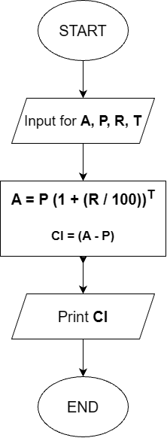
- STEP 1: Start
- STEP 2: Take input for A (Final Amount (Principal + Interest)), P (Principal (Initial Amount)), R (Rate of Interest), T (Time)
- STEP 3: A = p (1 + (R / 100))^{T} CI = (A – P)
- STEP 4: Print CI
- STEP 5: End

Print counting from 1 to n
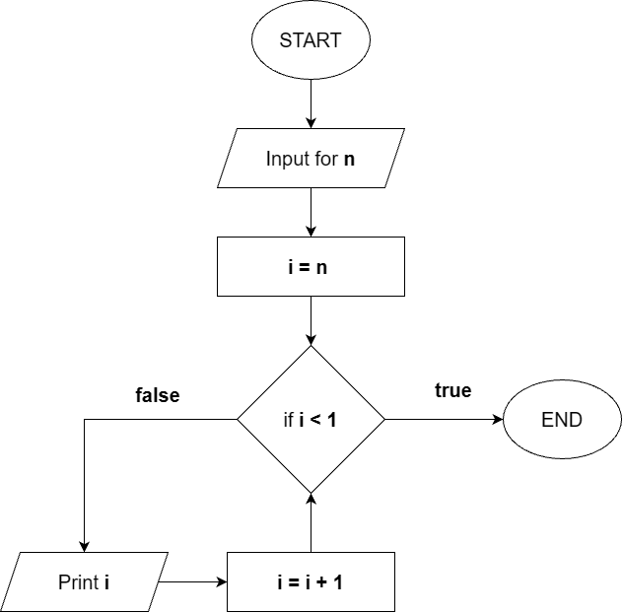
- STEP 1: Start
- STEP 2: Take input for n
- STEP 3: i = n
- STEP 4: if i < 1 Go to STEP 7
- STEP 5: Print i
- STEP 6: i = i – 1 Go to STEP 4
- STEP 7: End

Print factorial of a number n
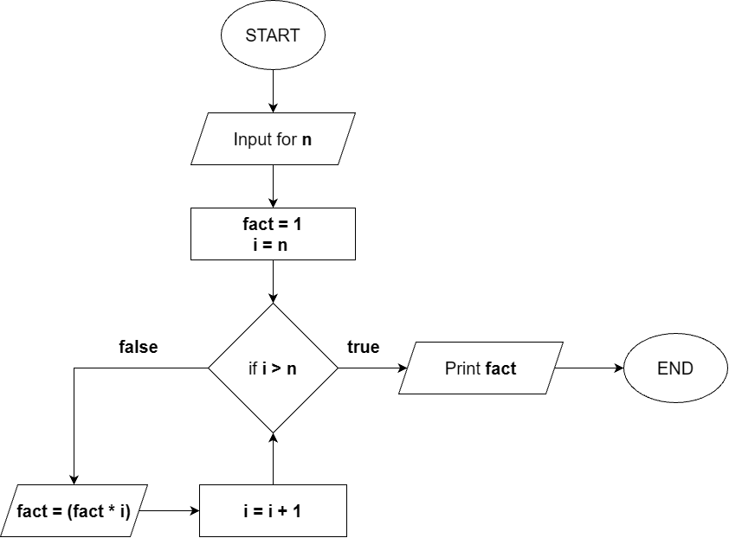
- STEP 1: Start
- STEP 2: Take input for n
- STEP 3: fact = 1, i = 1
- STEP 4: If i < n Go to STEP 7
- STEP 5: fact = (fact * i)
- STEP 6: i = i + 1 Go to STEP 4
- STEP 7: Print fact
- STEP 8: End

Check if a number is prime or not
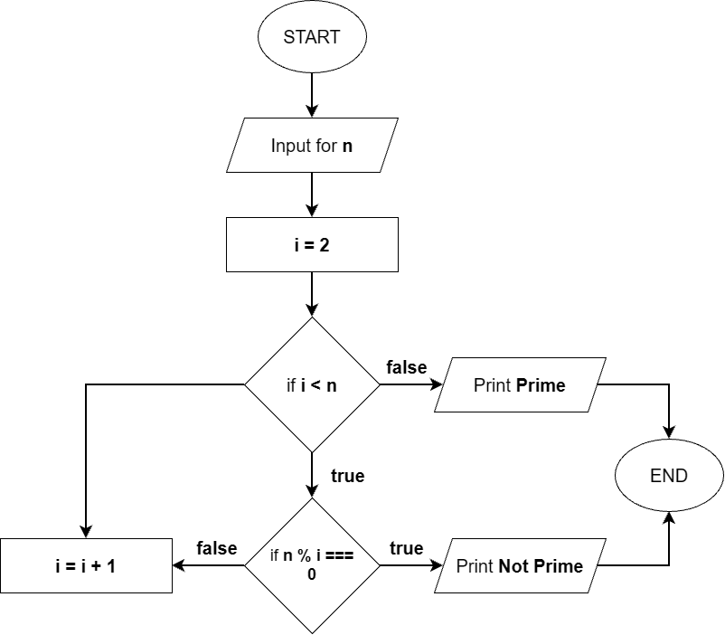
- STEP 1: Start
- STEP 2: Take input for n
- STEP 3: i = 2
- STEP 4: if i < n (true) Go to STEP 6
- STEP 5: Print Prime Go to STEP 9
- STEP 6: If n % i === 0 (true) Go to STEP 7
- STEP 6: If n % I !== 0 (false) Go to STEP 8
- STEP 7: Print Not Prime Go to STEP 9
- STEP 8: i = I + 1 Go to STEP 4
- STEP 9: End

Find max of 2 numbers
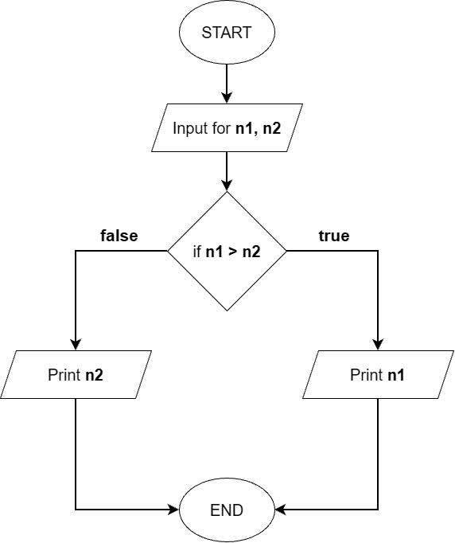
- STEP 1: Start
- STEP 2: Take input for n1, n2
- STEP 3: If n1 > n2 (false) Go to STEP 5
- STEP 4: Print n1
- STEP 5: Print n2
- STEP 6: End

Add n numbers from user input & print
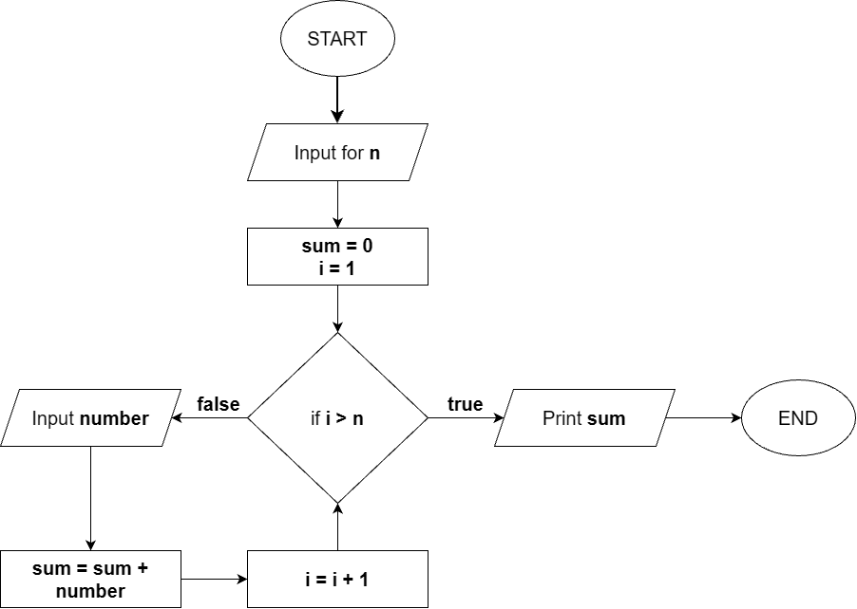
- STEP 1: Start
- STEP 2: Take input for n
- STEP 3: sum = 0, i = 1
- STEP 4: If i > n (true) Go to STEP 8
- STEP 5: Input number
- STEP 6: sum = sum + number
- STEP 7: i = i + 1 Go to STEP 4
- STEP 8: Print sum
- STEP 9: End

LECTURE 02 – HOW A JAVA PROGRAM RUNS

Program Execution
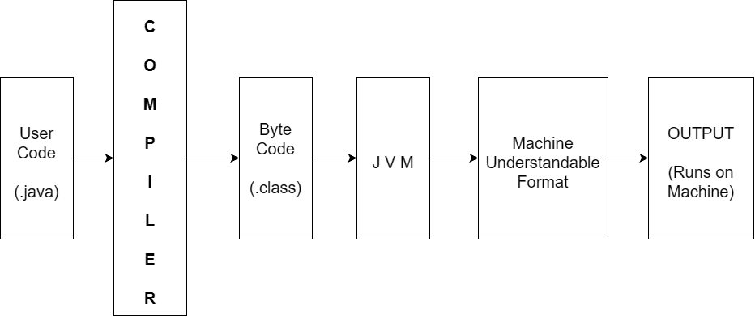

User Code (.java file)
- Code written by the developer / programmer in Java Language.
- Saved with .java extension.
- Example filename: xyz.java
- Human readable but machine cannot directly understand or run it.
- Cannot be directly fed to the machine – need translate layer.

Compiler
- A Compiler is a translation layer that converts our human-readable Java source code (.java file) into a Byte Code (.class file).
- Input: User code (.java)
- Output: Byte Code (.class)
- It is Layer 1 of translation.
- Compiler support comes from JDK.
- Does not run the code – only converts it.
- Analogy: We speak Hindi compiler translates Hindi to English (intermediate language) another layer translates English to French (Machine Language).

Byte Code (.class file)
- Byte Code is an intermediate format of code generated by the compiler that is neither human-readable nor directly machine readable.
- Key Characteristics:
- Saved with .class extension.
- Neither human nor machine can understand it directly.
- But it is Platform Independent.

Platform Independence – What does it means ?
OPERATING SYSTEM | CAN BYTE CODE RUNS ?
Windows | Yes (via JVM) ✅
MacOS | Yes (via JVM) ✅
Linux | Yes (via JVM) ✅
Any OS | Yes (via JVM) ✅
- Key Point:
- The SAME byte code can run on ANY operating system using JVM – ths is what makes Java “Write Once, Run Anywhere”.

JVM (Java Virtual Machine)
JVM (Java Virtual Machine) is a software that takes Byte code as input, converts it into Machine Understandable Format, and executes / runs it on our machine.
Two Jabs of JVM:
- Translation: Converts Byte Code Machine Understandable Format.
- Executes: Runs that Machine Understandable code on our machine.

Key Points:
- Without JVM, Java program cannot run – period.
- JVM is platform dependent (different JVM for windows / MacOS / Linux).
- But Byte code is platform independent – same byte code, different JVMs.
- JVM is a component inside JRE.

Analogy:
- Compiler
- Hindi to English translator.
- JVM:
- English to French translator + person who delivers the message.

JRE (Java Runtime Environment)
- JRE (Java Runtime Environment) is a combination of JVM + Libraries).
- It provides the environment needed to run java applications.
JRE = JVM + Libraries

What are Libraries ?
- Pre-written code that java provides out of the box.
- Used for common tasks like:
- Printing output (system.out.println)
- Taking input (scanner)
- Math operations, String handling, etc.
- We don’t write this code ourself – it’s already written & available.
- Example:
- system.out.println()
- The logic for printing is inside a library.

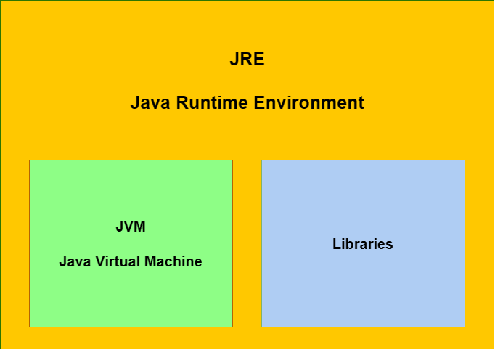

JDK (Java Development Kit)
- JDK (Java Development Kit) is the complete package that allows us to both develop and run java application.
- It contains JRE + Development tools
JDK = JRE + Development Tools
JRE = JVM + Libraries + Compiler + Debugger + Other Utilities

What’s inside JDK:
TOOL | PURPOSE
Compiler | Converts .java to .class (Byte Code)
Debugger | Helps find & fix error in code.
JRE | Contains JVM + Libraries to run program.
Other Utilities | Additional Development Tools.

JDK (Java Development Kit)
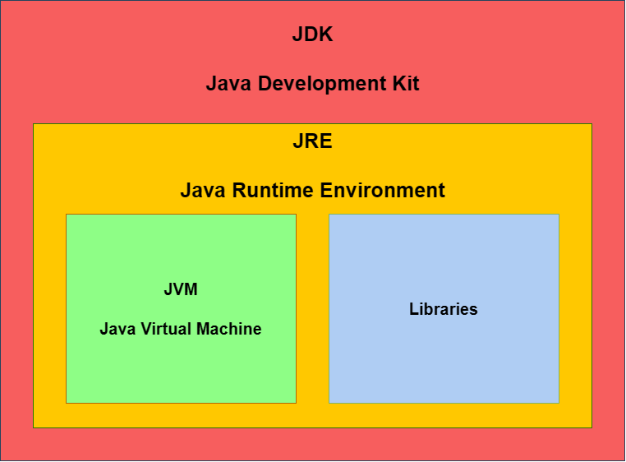

Lecture 02 – Questions

What is JIT Compilation & how does JVM use it for Optimization ?

What is the difference between Compiler vs Interpreter ?

Is Java Compiled, Interpreted, or both ?

LECTURE 03 – IDE SETUP FOR CODING

Ways to write Java
- Online Compiler: Quick, no setup needed
- IntelliJ IDEA: Professional IDE used in Companies

Option 1: Online Compiler

What is it ?
- A browser-based compiler – no installation needed.
- Built by CodeHelp team themselves.
- Write code see output, all in one place.

How to use:
- STEP 1: Go to CodeHelp website
- STEP 2: Navigate to Explore Quick Compiler
- STEP 3: Select language Java
- STEP 4: Write your Java code in the code window
- STEP 5: Provide input (if needed) in input window.
- STEP 6: Click Run Output appears in the output window.

Structure of Online Compiler UI
SECTION | PURPOSE
Code Window | Write your Java Code here
Input Window | Provide input values for your program
Output Window | See the result / output of your code.

Where to use Online Compiler ?
- Quick testing of small program.
- When we don’t want to install anything.
- Beginners just starting out.
- Single file programs.

Limitations:
- Cannot manage multiple files easily.
- Not suitable for large projects.
- Less features as compared to full IDE.

Option 2: IntelliJ IDEA (Professional IDE)

What is IntelliJ IDEA (Professional IDE)
- IntelliJ IDEA is a professional Integrated Development Environment (IDE) used widely in companies for Java Development.
- It provides a complete environment to write, compile, debug, and run Java Code.

Why IntelliJ IDEA ?
- Used by majority of companies for Java Development.
- Support multiple files management.
- Organized project structure.
- Built-in compiler, debugger, and other tools.
- Industry standard tool.

IntelliJ IDEA Setup Steps:

STEP 1: Download
- Search IntelliJ IDEA Community Edition.
- Go to first link (JetBrains Official Website).
- Download the correct version for your OS:
- Windows .exe file
- macOS .dmg file
- Linux .tar.gz file

NOTE:
- Always download Community Edition – it’s Free.
- Ultimate Edition is PAID.

STEP 2: Install
- Windows:
- Double click .exe file.
- Next Next Finish
- macOS:
- Double click .dmg file
- Drag IntelliJ to Application folder.
- Open from Applications.

STEP 3: Create New Project
- Open IntelliJ IDEA.
- Click New Project
- Enter Project Name (e.g., Java DSA).
- Set location Desktop (or preferred folder).
- Build System IntelliJ
- JDK Select / Download JDK (auto-download if not present).
- Click Create
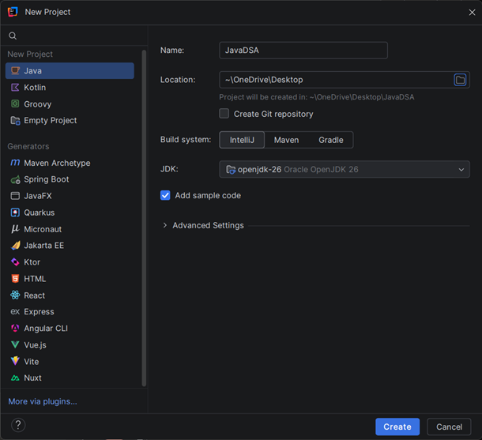

IMPORTANT:
- When we create a project, IntelliJ automatically download & installs JDK if not already present on our system.
- This JDK give us the complete development environment (Compiler + JVM + Libraries).

STEP 4: Project Structure
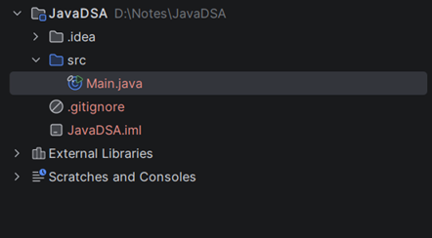
JavaDSA/ | Project Root
src/ | Source Folder (write code here)
Main.java | Default Java file
External Libraries/ | Pre-loaded Java Libraries (JRE)

STEP 5: Create our own Java File
- Right click on src folder.
- Click New
- Click Java Class
- Enter class name (e.g., maggi).
- File created: maggi.java
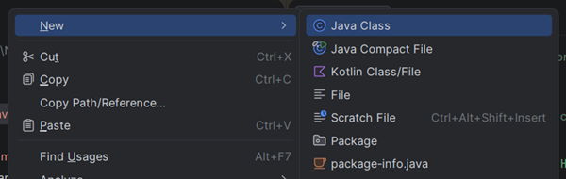
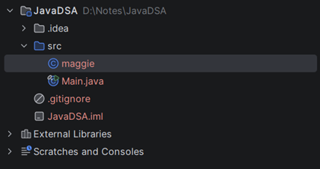
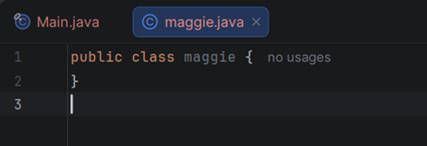

STEP 6: Run a Java File
- Open any .java file
- Click the GREEN ARROW button on the left of main
- Select Run
- Output appears in the bottom console window.

Online Compiler vs IntelliJ IDEA
FEATURE | ONLINE COMPILER | INTELLIJ IDEA
Setup needed | No ❌ | Yes (one-time) ✅
Internet Required | Yes ✅ | No ❌
Multiple files | Limited ❌ | Yes ✅
Project Structure | No ❌ | Yes ✅
Debugger | No ❌ | Yes ✅
Used in Companies | Rarely ❌ | Yes (Industry Standard) ✅
Best for | Quick testing | Full Development

Lecture 03 – Questions

What is an IDE ?

Why is IntelliJ IDEA preferred for Java Development ?

What happened when we click Run in IntelliJ ?

What is the difference between Online compiler & IDE ?

